Vocabulary
1 Dopasuj podpisy do obrazków.
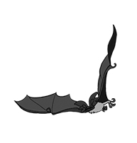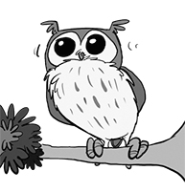
a
b
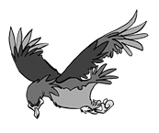
c
d
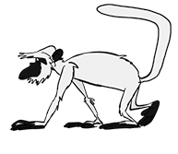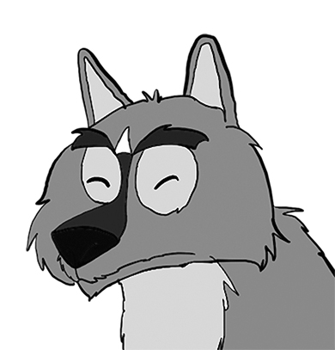
e

f
1 e monkey 4 eagle
2 lion 5 wolf
3 owl 6 bat

2 Uzupełnij brakujące litery w przymiotnikach.
1 Monkeys are funny.
2 Penguins are c _ _ _.
3 Sharks are d _ _ g _ r _ _ s.
4 Dolphins are f _ _ _ _ _ _ y.
5 Elephants are i _ t _ _ _ i _ _ _ t.
6 Owls are b _ _ _ t _ _ u _.

Grammar
3 Uzupełnij zdania podanymi przymiotnikami w stopniu wyższym.
1 Her bedroom is ___nicer_ (nice) than my bedroom.
2 The weather is __________ (good) today than yesterday.
3 Bats are _______________ (ugly) than owls.
4 French is ________________ (difficult) than English.
5 England is ____________ (cold) than Africa.
6 Elephants are ____________ (big) than monkeys.

4 Zakreśl właściwą formę.
1 This hill is the windiest / windier place in the country.
2 I got the goodest / best marks in the class.
3 Which is smallest / the smallest animal in the world?
4 Today is the hottest / hotest day of the year.
5 I think dolphins are the beautifulest /
most beautiful animals in the world.
6 She’s the worst / worse singer in the band.

5 Uzupełnij dialog wyrazami z ramki.
than the nicest nicer as more good
Molly It’s Mum’s birthday soon. I want to buy her a better present ¹__than__ last year. We got her chocolates. What about a book this year?
Sam A book is ²__________ expensive than chocolates. What about flowers?
Molly Well, a book isn’t as expensive ³__________ flowers.
Sam I like flowers. I think flowers are ⁴__________ present in the world.
Molly But they don’t taste as ⁵__________ as chocolates!
Sam That’s true. And chocolates look ⁶__________ than a book.

Speaking
6 Ponumeruj kwestie dialogu we właściwej kolejności.
Ryan It’s really good. It’s better than last week.
It’s warm and sunny. __
Ryan Hi, Tom! How are you? 1
Ryan Is it cold? __
Tom It’s freezing. I’ve got all my winter clothes on. What’s it like there? __
Tom I’m OK, thanks. But the weather
is terrible. __
Tom That sounds good. It’s really foggy here! __

Reading
7 Przeczytaj tekst. Zakreśl w poniższych zdaniach właściwą odpowiedź.
The West Midland Safari Park is one of the most interesting places to visit in the UK.
It is not the biggest safari park in the world but you can see some amazing animals, such as elephants, tigers, lions, zebras and camels. There are over six hundred animals there, including some white lions. These lions are very unusual and you don’t see them very often.
You can drive around the park slowly in a car or there’s also a train that goes through the middle of the park. The train is faster than the car, of course. There is also a bus with a tour guide so you can find out more information from the guide.
You have the chance to feed some of the animals, too. But they only eat special animal food, so don’t give them sandwiches or chocolate!

1 West Midland Safari Park is a boring /
an interesting place to visit.
2 You can see animals from the UK / all over the world there.
3 There are more than 600 white lions / animals in the park.
4 You can drive / walk slowly around the safari park.
5 You can learn new information on the safari park train / bus.
6 You can / can’t feed the animals your picnic.
Listening
8 Posłuchaj nagrania i uzupełnij brakujące wyrazy w tabeli.
04
¹___giraffe__ | It’s got a long ²__________ and spots.
³___________ | It lives in the sea and it’s got ⁴__________ legs.
⁵___________ | It doesn’t live in the sea and it’s very ⁶__________.

