Vocabulary
1 Popatrz na obrazki i uzupełnij wyrazy.
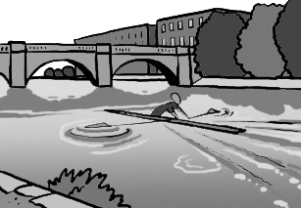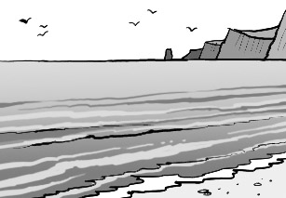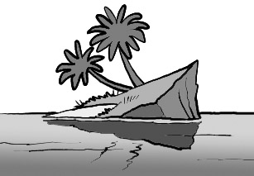
1
2
3
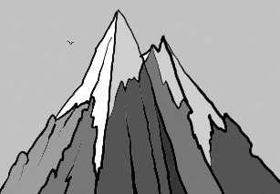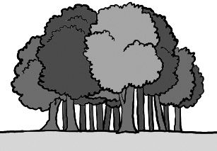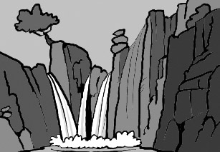
4
5
6

1 a river 4 a m
2 the s 5 w
3 an i 6 a w

2 Uzupełnij wyrazy.
1 I can’t cycle up the h i l l .
2 There are two horses in the f_ _ _ _ .
3 Let’s have a picnic on the b_ _ _ _ .
4 There’s a small boat on the l_ _ _ .
5 The v_ _ _ _ _ is beautiful.
6 Can you swim to the i_ _ _ _ _ ?

Grammar
3 Uzupełnij zdania właściwą formą przymiotników w stopniu wyższym.
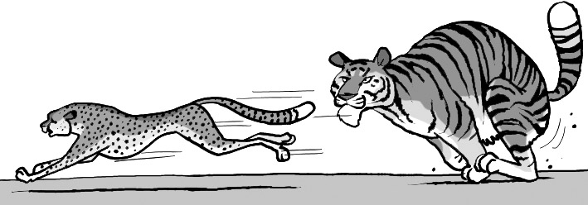
fast
big
1 The tiger is ____bigger____ than the cheetah.
2 The cheetah is _____________ _ than the tiger.
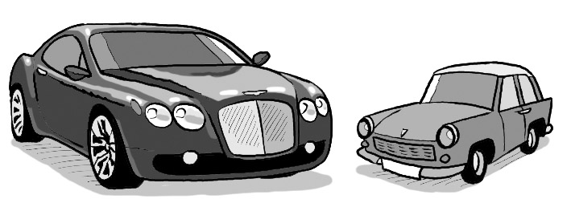
A
B
expensive
cheap
3 Car A is _____________ _____ than car B.
4 Car B is _____________ _____ than car A.
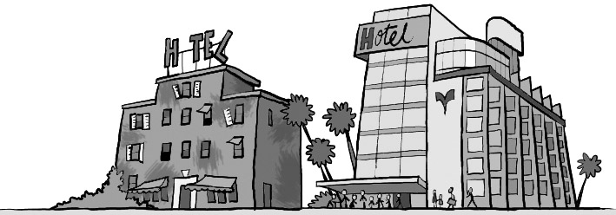
A
B
old
popular

5 Hotel A is _____________ _____ than hotel B.
6 Hotel B is _____________ _____ than hotel A.

4 Napisz przymiotniki w stopniu najwyższym.
1 deep the deepest
2 nice ______________________________
3 wet ______________________________
4 funny ______________________________
5 difficult ______________________________
6 bad ______________________________

5 Uzupełnij zdania. Użyj przymiotników z nawiasów w stopniu wyższym lub najwyższym. Nie zapomnij o użyciu than tam, gdzie jest to konieczne.
 | How old? | How tall? | How heavy?
Jon | 12 | 156 cm | 54 kg
Sue | 13 | 150 cm | 52 kg
Pat | 14 | 155 cm | 48 kg
1 Jon is younger than Pat. (young)
2 Sue is ___________________ Jon. (old)
3 Jon and Sue are _______________ Pat. (heavy)
4 Jon is _______________________. (tall)
5 Pat is _________________ Jon and Sue. (old)
6 Jon is ____________________. (heavy)

Reading
6 Przeczytaj tekst Tima. Oznacz zdania jako prawdziwe P lub fałszywe F.
There are many beautiful places to visit in my country. My favourite places are near the coast. I live in a big city, and it’s the furthest place from the coast in the country!
When I go on holiday, I usually go swimming. My friends often hire a boat and go fishing, but I prefer to be in the water. I don’t need a sandy beach. It’s more interesting to swim near the cliffs, because there aren’t many people there, and you can see some beautiful fish. The rocks can be a bit dangerous, though. The only thing that I’d like to have on holiday is hotter weather, but there are other things that are more important to me.
1 Tim prefers the city to the coast. F
2 Tim lives a long way from the sea.
3 Tim’s friends often go fishing on holiday.
4 Tim’s friends have got a boat.
5 Like likes to watch fish.
6 Tim likes cold weather.

Listening
7 Posłuchaj dialogu. Oznacz zdania jako prawdziwe P lub fałszywe F
06
1 Paul is raising money for a holiday. P
2 The walk is ten kilometres.
3 Paul isn’t a very good walker.
4 Paul’s grandad likes walking.
5 Paul hasn’t got good walking boots.
6 Jack is on holiday.

Speaking
8 Przeczytaj rozmowę Fiony i Adama. Podkreśl właściwą formę.
Fiona Do you ¹ like / liking pop music?
Adam It’s OK. But ²on / in my opinion, hip hop is better.
Fiona Which is your favourite hip hop band?
Adam The Black Eyed Peas. I ³think /
don’t think they’re great.
Fiona I don’t ⁴opinion / agree. I like pop groups like Little Mix. They’re really good.
Adam Really? I think they’re terrible. What’s your ⁵favourite / best TV programme?
Fiona The Simpsons. It’s the funniest programme on TV at the moment.
Adam I think so, too. And I don’t ⁶usually / never like cartoons.

